1 install orthanc
My server os is ubuntu 22
sudo apt install orthanc

2 install plugins you need
Some plugins can be installed like:
sudo apt install orthanc-dicomweb
sudo apt install orthanc-webviewer

some plugins need to be downloaded into the orthanc plugins dir,
like this:
wget https://orthanc.uclouvain.be/downloads/linux-standard-base/orthanc-authorization/0.9.2/libOrthancAuthorization.so

3 config
config files:
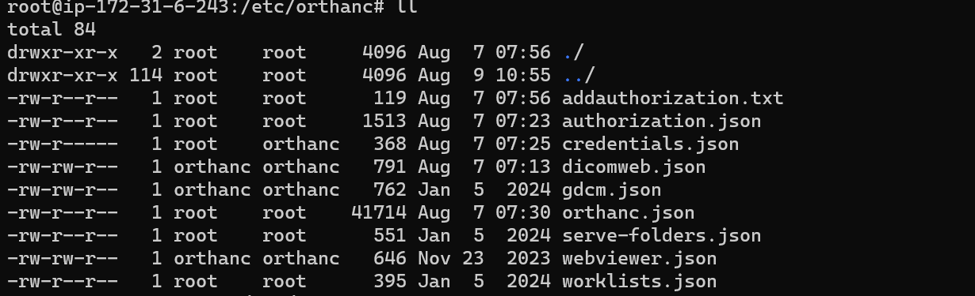

orthanc.json is the most important config file:
Orthanc server is accepting remote connections, but is using the default username and password in credentials.json , or has user authentication explicitly turned off. Please carefully read your logs and review your configuration, especially options RemoteAccessAllowed, AuthenticationEnabled, and RegisteredUsers.

other config files are based on what plugins you are installing. Like dicoweb.json:
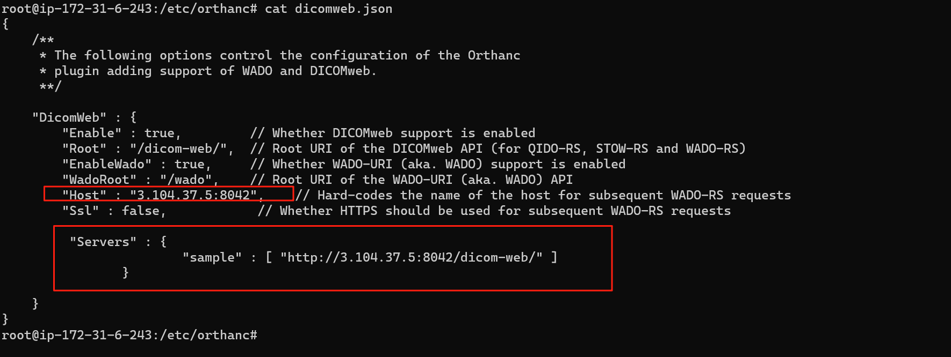
If you want to use othanc-Authorization, this is my example:
First , download the right version to the /usr/share/orthanc/plugins directory
Then config the authorization.json
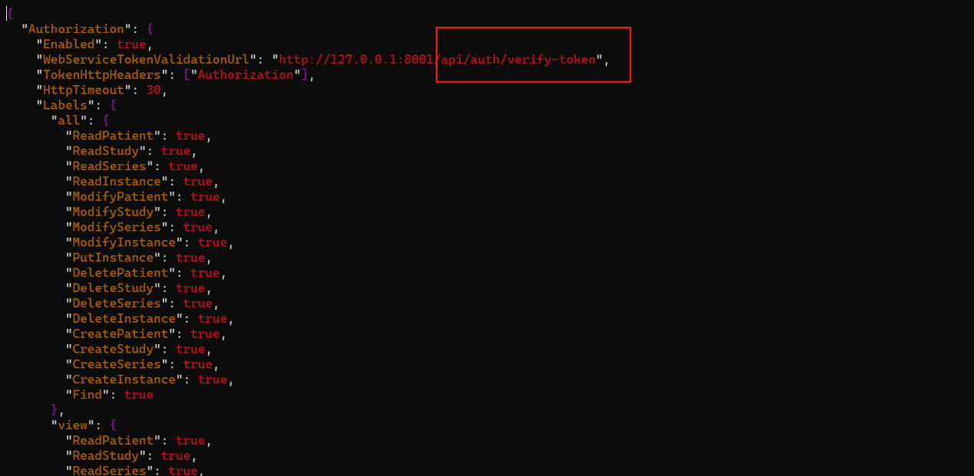
"WebServiceTokenValidationUrl": is the backend api which can verify the token
"TokenHttpHeaders": ["Authorization"], is the token in the http-head where the orthanc can take from and sent it to the WebServiceTokenValidationUrl

4 server start
server start: service orthanc restart
see logs:
tail -200f /var/log/orthanc/Orthanc.log
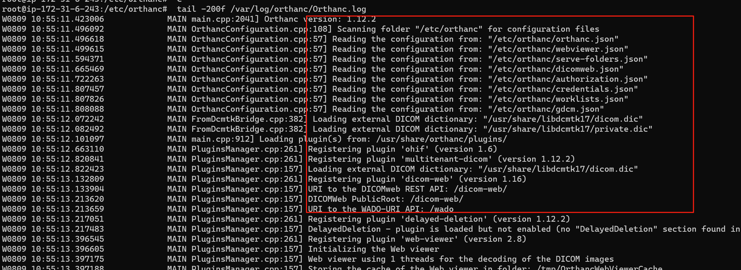
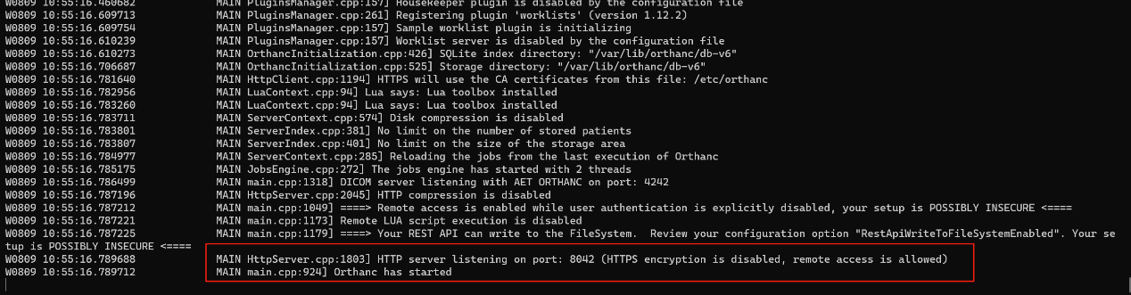

After we start Orthanc, we can clearly see which configuration files are loaded, which plugins are loaded, the port number, and whether Orthanc has started or not.
These are my Orthanc configuration files. Be cautious, as different Orthanc versions may have slight differences in their configurations. My Orthanc version is 1.12.2.
